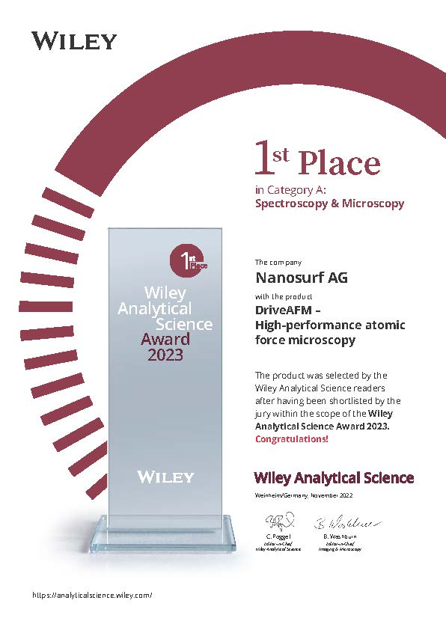
Press Release
18 November 2022
Nanosurf’s DriveAFM wins Wiley Analytical Science Award 2023
We are pleased to share that Nanosurf’s DriveAFM was selected by Wiley’s readership as the winner of the 2023 Wiley Analytical Science Award in the category Spectroscopy and Microscopy.
For Nanosurf this is not only a reward for the outstanding work of our development and engineering teams, who designed and built this instrument with the goal to create a stable, high-end AFM for diverse types of research that is still easy to use. It is also a confirmation that after only two years in the market, the DriveAFM is now established as one of the most sought-after AFMs in the very competitive high-end sector.
At the award ceremony Dr. Jonathan Adams, who was involved in development from the very beginning, expressed what an honour it is to have been awarded this 1st place: “Developing the DriveAFM was a fun and challenging project, and a real team effort, because of the ambitious goal to achieve the highest level of AFM performance while implementing novel features like photothermal excitation and full motorization in a tip-scanning AFM. We had the freedom to imagine things from the ground up, and we are all really proud of the result and the recognition given to us by the jury and the readers of Wiley.”
https://analyticalscience.wiley.com/do/10.1002/was.000700103
A recording of the award ceremony can be viewed here: https://events.bizzabo.com/WASconferenceFall2022/agenda/session/1035190
A huge thank you to all who gave us their trust by voting for the DriveAFM. Stay tuned for continuing expansion of the DriveAFM’s functionality suite. A lot more is to come in the near future.

About DriveAFM:
The DriveAFM was released in 2020 and is Nanosurf’s flagship AFM platform based on a tip-scanning design combining atomic resolution, imaging capability from the atomic scale through 100 μm, full motorization, and fast scanning. With innovations in scanner design and optical beam path engineering, the DriveAFM offers superior research performance.
About Nanosurf:
Nanosurf was founded in 1997 in Liestal, Switzerland, and has since become one of the most trusted and established AFM brands in the market today. While Nanosurf continues to develop and manufacture AFMs at its Swiss headquarters, it is a global company with direct sales, service and support operations in China, Germany, India, Singapore, the UK and US.

